Assignment 3
Name: Aaviraj Nikumbh
PRN: 24070126123
Batch: AIML B2

Link - https://github.com/AaviRaj1702/Java_Files

Title: Book Inventory System: Develop a Book class using constructors and exception handling. Store and manage records using ArrayList.

Code 1) Book
public class Book { public String title; public String author; public String ISBN; public String genre; public int price;

// Default constructor public Book() {
this.title = ""; this.author = ""; this.ISBN = ""; this.genre = ""; this.price = 0;
}

public Book(String t, String a, String i, String g, int p) throws InvalidPriceException , InvalidGenreException
{
this.title = t; if (p < 0) {
throw new InvalidPriceException("Price cannot be negative: " + p);
}
if (!g.equalsIgnoreCase("Action") CC !g.equalsIgnoreCase("Biography") CC
!g.equalsIgnoreCase("Best") CC !g.equalsIgnoreCase("Boring") CC
!g.equalsIgnoreCase("Thriller")) {
throw new InvalidGenreException("Invalid genre: " + g);
}
this.author = a; this.ISBN = i;
this.genre = g; this.price = p;
}

// Copy constructor public Book(Book b) {
this.title = b.title; this.author = b.author; this.ISBN = b.ISBN;
this.genre = b.genre; this.price = b.price;
}

public String getTitle() {

return title;
}
public String getAuthor() { return author;
}

public String getISBN() { return ISBN;
}

public String getGenre() { return genre;
}

public int getPrice() { return price;
}
}
Code 2) MainBook
import java.util.ArrayList;

public class MainBook {
public static void main(String[] args) throws InvalidGenreException , InvalidPriceException {
try {
Book b1 = new Book("How to get 9 CGPA", "Kavish", "978", "Boring", 500);

ArrayList<Book> alb = new ArrayList<>(); alb.add(b1);
Book b2 = new Book("How to get 0 CGPA", "robert", "978", "Tp", 300); alb.add(b2);
Book b3 = new Book("Harry Potter", "K J Rowling", "978", "Best", 400); alb.add(b3);

Book b4 = new Book(b3);
b4.title = "Harry Potter and the Sorcerer's Stone"; b4.price = 450;
alb.add(b4);

Book b5 = new Book("Inferno", "Dan Brown", "978", "Thriller", 350);

Book b6 = new Book("My experiment with truth", "Mystery", "978", "Biography", -
400);
ArrayList<Book> alb2 = new ArrayList<>(alb); alb2.add(b5);
alb2.add(b6); alb.addAll(alb2);

System.out.println("Books of genre action"); alb.forEach(b -> {
if ("Action".equalsIgnoreCase(b.getGenre())) { System.out.println("Title: " + b.getTitle()); System.out.println("Author: " + b.getAuthor()); System.out.println("ISBN: " + b.getISBN()); System.out.println("Genre: " + b.getGenre()); System.out.println("Price: " + b.getPrice()); System.out.println();
}
});
alb.forEach(e -> {int w = ((b1.getPrice()+ b2.getPrice()+ b3.getPrice()+ b5.getPrice()+ b6.getPrice())/5); System.out.println("Average Price: " + w);});
} catch (InvalidPriceException e) { System.out.println(e.getMessage());
}
}
}

Code 3) InvalidGenreException

public class InvalidGenreException extends Exception { public InvalidGenreException(String m) {
super(m);
}
}

Code 4) InvalidPriceException

public class InvalidPriceException extends Exception { public InvalidPriceException(String m) {
super(m);
}
}

Output)

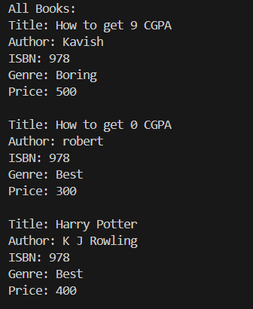
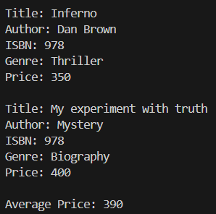
Exception Handling:-
- Negtive Price
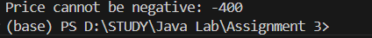

- Invalid Book Genre
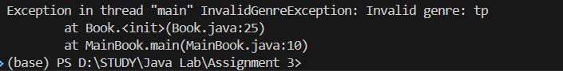

Github:
https://github.com/AaviRaj1702/Java_Files

